**Basic electrical quantities**

The international standard units, *Système international d'unités* (SI units), that are commonly used for electrical quantities include coulombs, amperes, volts, ohms, watts and joules.

The fundamental unit of electricity is the negative charge of the electron or the positive charge of an ionised atom that has lost a single electron (resulting from the positive charge on the protons in the nucleus outnumbering that of the remaining electrons).

Electrical charge is measured in coulombs (symbol C). The charge on a proton is approximately 1.6 × 10−19 C, while the charge on an electron is the same magnitude but has the opposite sign (approximately −1.6 × 10−19 C). An electrical current is a flow of electric charge, measured in amperes (symbol A), where a current of one ampere is a total charge of one coulomb flowing in one second. Ampere is often abbreviated to amp.

In a circuit, positive and negative electric charges typically flow in the opposite direction to each other, as shown in Figure 8. This course will use conventional current flow, the predominant convention in the electronics industry, which is indicated in the direction taken by positive charges. In metal wires, the current is carried by electrons, which move in the opposite direction. This was not known at the time the convention was established.

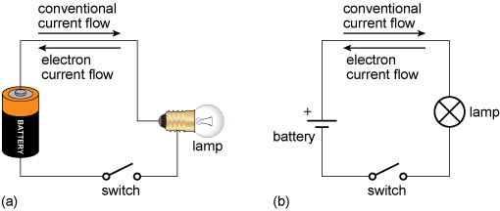

**Figure 8**  Current flow in an example circuit showing a light bulb (lamp) powered by a battery: (a) schematic using pictures to represent the components; (b) the same circuit using standard circuit schematic symbols. By convention, current flows in the opposite direction to the flow of electrons.

[Long description](https://www.open.edu/openlearn/ocw/mod/oucontent/view.php?id=68374&extra=longdesc_idm45830426354416&clicked=1)

A quantity closely related to current is voltage. Voltage is a measure of the potential difference between two points. A potential difference of one volt (symbol V) will drive a coulomb of charge through a resistance of one ohm every second. Note that we usually refer to current flowing *through* a component such as a resistor, but to the voltage being *across* the component (because two points are required to define the voltage). Voltage can be expressed as the energy per coulomb of charge (J C−1).

# Relationships between quantities

For many materials, current and voltage are directly proportional to each other over a wide range of values, with the resistance as the constant of proportionality, so

 voltage = current × resistance

Such materials are said to obey *Ohm’s law* and are said to be ohmic. However, not all materials are ohmic in nature.

As current flows through a circuit, it transfers energy. When it flows through a material that has a non-zero resistance, this energy is used (for instance, to light a bulb or run a motor) or dissipated as heat (which is why electronics circuits sometimes feel warm, and why computers need cooling fans). As in every other context, the rate of change of energy is known as power, and can be measured in watts (symbol W).

In the context of an electrical current flowing through a resistor, the power used or dissipated can be calculated by multiplying the current flowing through it by the potential difference across the resistor, giving

 power (watts) = current (amps) × potential difference (volts)

Before you move on, Table 1 recaps the electrical quantities mentioned so far, their units and how they relate to each other.

## Table 1  Electrical quantities and their units

|  |  |  |
| --- | --- | --- |
| **Quantity** | **Unit** | **Equation** |
| energy | joules, J |  |
| voltage (potential difference) | volts, V  or  energy per charge, joules per coulomb, J C−1 |  |
| current | amps, A  or  charge per second, coulombs per second, C s−1 |  |
| power | watts, W  or  energy per second, joules per second, J s−1 | power = voltage × current |
| resistance | ohms, Ω | resistance = voltage ÷ current |

All the quantities listed in Table 1 can be measured in larger or smaller multiples of their standard unit using SI prefixes, which make it easier to read values at a glance. Some of these are listed in Table 2.

## Table 2  Common prefixes for SI units

|  |  |  |  |  |
| --- | --- | --- | --- | --- |
| **Prefix** | **Symbol** | **Multiple of standard unit** | | **Example** |
| micro | µ | one millionth | 10−6 | microamp, µA |
| milli | m | one thousandth | 10−3 | millivolt, Mv |
| kilo | k | one thousand | 103 | kilo-ohm, kΩ |
| mega | M | one million | 106 | megawatt, MW |

As you gain experience in electronics, try to notice the values of currents, voltages and other quantities for the components you see, and note the associated effects they are having on the circuit. This will help you to choose values when you design, and to troubleshoot when designs or circuits do not work.

# Passive Components in AC Circuits

Passive components are those circuit devices which can only reduce the electrical power applied to them and not increase it.

Electrical and electronic circuits consist of connecting together many different components to form a complete and closed circuit. The three main passive components used in any circuit are the: **Resistor**, the **Capacitor** and the **Inductor**. All three of these passive components have one thing in common, they limit the flow of electrical current through a circuit but in very different ways.

Electrical current can flow through a circuit in either of two ways. If it flows in one steady direction only it is classed as direct current, (DC). If the electrical current alternates in both directions back and forth it is classed as alternating current, (AC). Although they present an impedance within a circuit, passive components in AC circuits behave very differently to those in DC circuits.

Passive components consume electrical energy and therefore can not increase or amplify the power of any electrical signals applied to them, simply because they are passive and as such will always have a gain of less than one. Passive components used in electrical and electronic circuits can be connected in an infinite number of ways as shown below, with the operation of these circuits depending on the interaction between their different electrical properties.

# DC Circuits Basics

### Introduction

A circuit that can be AC or DC is the combination of active elements (power supply sources) and passive elements (resistors, capacitors and inductors). Thus, the circuit theory or analysis helps to understand the circuit behavior or characteristics by finding out the voltages and currents in various elements in a circuit by using different techniques. So let us discuss in brief about basic concepts of electricity before we could deal with DC circuit theory in later articles.

# DC Circuit and electrical power review

Review the components of a circuit and their symbols such as battery, resistor, and switch. Analyze how the power of a resistor is related to the current and electric potential difference across the resistor.

| **Equation** | **Symbols** | **Meaning in words** |
| --- | --- | --- |
| P=IΔVP = I \Delta VP=IΔVP, equals, I, delta, V | PPPP is power, IIII is current, and ΔV\Delta VΔVdelta, V is electric potential difference | The rate at which energy is transferred from a resistor is equal to the product of the electric potential difference across the resistor and the current through the resistor. Scalar quantity with units of Watts (W\text WWstart text, W, end text). |

Resistors are electrical components that resist current and expends voltage within a circuit.

https://cdn.kastatic.org/ka-perseus-images/ecf2e0466dc3dc060d6405252796a21886222f34.png

Figure 1. Symbol for resistor.

### Battery (ϵ\epsilonϵ\epsilon)

Batteries are electrical components that provide electrical energy.

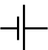

Figure 2. Symbol for battery. The short end is the negative terminal and the long end is the positive terminal.

Batteries have positive and negative terminals. The negative terminal is drawn with a short line, and the positive terminal is shown as a long line.

### Switch (SSSS)

Switches turn the flow of current through a circuit pathway on and off. When the switch is open, no current flows because there is a gap in the circuit (Figure 3).

https://cdn.kastatic.org/ka-perseus-images/fdc3780141ad8eab013417e63ab85a857c76a201.png

Figure 3. Symbol for open switch. No current flows through this location because the conductive pathway has a gap.

When the switch is closed, current can flow because the circuit is continuous (Figure 4).

https://cdn.kastatic.org/ka-perseus-images/2eb1e23640be0e574b9c6e82fd790c6362ac257b.png

Figure 4. Symbol for closed switch. Current can pass through this location because the circuit pathway is continuous.

### Node

A node (or junction) is a place where two or more circuit elements join together. Figure 5 below shows a single node (the black dot) formed by the junction of five electrical components (abstractly represented by orange rectangles).

Figure 5. A junction (highlighted in green) between 5 different electrical components.

A simple circuit contains the minimum amount of components that allow it to be a functional electric circuit: a voltage source εεεε (battery), a resistor RRRR, and a loop of wires for current IIII to flow around (see Figure 6 below). We usually ignore any resistance from the wires.

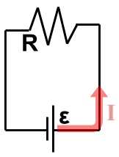

Figure 6. Simple circuit diagram.

In a simple circuit, the voltage supplied by the battery εεεε is the voltage expended by the resistor RRRR, and there is only one current IIII in the circuit.

### Closed circuit

A closed circuit has a continuous pathway for current to flow through. In other words, there are no gaps in the circuit.

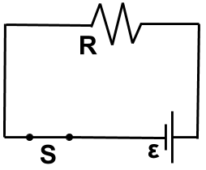

Figure 7. Diagram of a closed circuit.

### Open circuit

An open circuit has a gap in the circuit that does not allow current to flow through. The gap can be caused by an open switch, a broken component, or broken wire.

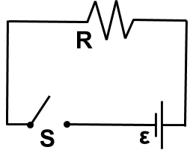

Figure 8. Diagram of a open circuit.

### Short circuit

A short is a pathway of zero resistance within a circuit (see the blue wire in Figure 9). When there is a short circuit, all the current flows across the short because the current prefers the path of least resistance.

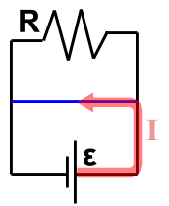

Figure 9. The blue wire has no resistance and is a short in this circuit. Since there is no resistance, all the current IIII flows across the blue wire instead of going through the resistor RRRR.

Figure 10 below shows how closing a switch SSSS can divert all the current from resistor R2R_2R2​R, start subscript, 2, end subscript. When switch SSSS is open (see Figure 10A), the current IIII flows out of the positive terminal of the battery towards node NNNN. Since the switch is open, no current flows through the switch and all the current flows through resistor R2R_2R2​R, start subscript, 2, end subscript. When the switch is closed (see Figure 10B), it forms a short around resistor R2R_2R2​R, start subscript, 2, end subscript. Now, once the current IIII reaches NNNN, the current bypasses R2R_2R2​R, start subscript, 2, end subscript and flows through the switch.

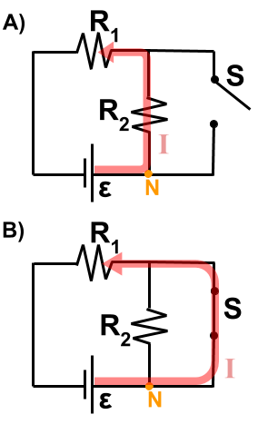

Figure 10. When the switch SSSS changes from open (diagram AAAA) to closed (diagram BBBB), resistor R2R_2R2​R, start subscript, 2, end subscript is shorted out and the current IIII bypasses it to go through the switch.

### **Basic Concept of Electricity**

According to the atomic theory, every material is made up from the atoms. This atom consists of centrally charged nucleus with a surrounded electrons based on Niels Bohr atom model. The nucleus consists of neutrons and positively charged protons. Electrons are negatively charged particles and rotate around the nucleus. This atom has an equal number of protons and electrons and a great force of attraction exist between these opposite charges results the electrons to track the nucleus.

Bohr’s model gives the distribution of electrons in each shell of an atom. The most importantly the valence shell which is an outermost cell from the nucleus consists of eight electrons and never more than that. These electrons are at furthermost distance from the nucleus so some extra energy is required to make these electrons free. These electrons flow gives the electricity. But number of electrons in the outermost valence shell decides the electricity flow because the energy of the shell is shared by the electrons in it. Each electron has one eight of the shell’s energy if that valence shell has eight electrons.

Hence great amount of external energy is required to make the electrons free so that the electricity is produced. Generally the materials which are not having free electrons in the outermost cell are called as insulators. Typically insulators have five to seven valence electrons in its valance shell. In other hand materials with one valence electron requires a little energy to free the electrons, so that the current is produced and the materials are called as conductors. Typically conductors have two or three valence electrons. These good conductors include silver, copper, aluminum, gold, etc. In prior to this, materials with four valence electrons that have both conductor and insulator properties called as semiconductors.

As from above atomic theory, the flow of electrons gives the electricity. We know that like charges repel whereas unlike charges attract. The separation the charges makes negative charges to accumulate at one terminal and positive charges to other terminal with the application of source. The current starts to flow when the path is made between these two charges. The unit of the charge is Coulomb and it has a charge of 6.25 X 1018 electrons. The external force or voltage applied causes the charge to move and the rate at which the charge flow is decided by the amount of voltage applied.

### **Introduction to Simple DC Circuit and Its Parameters**

We know that the electricity is of two types, Alternating Current (AC) and Direct Current (DC). A circuit that deals with AC is referred to as AC circuit and a circuit with DC source is termed as DC circuit.  As of now we only discuss about DC circuit and its theory. The DC source allows the electricity or current to flow with an unvarying polarity that doesn’t change with time. A simple DC circuit is given in below figure to make the reader get aware of DC circuit components and its parameters.

[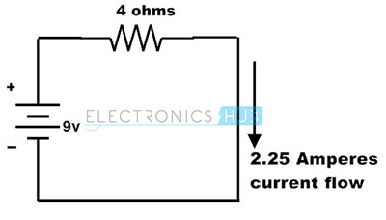](https://www.electronicshub.org/wp-content/uploads/2015/02/3.Simple-dc-circuit-model.jpg)

The above DC circuit consists of the voltage source and resistance with a specific current flow. So let us know about these parameters in brief.

#### Electric Voltage

The potential difference between two points or voltage in an electric circuit is the amount of energy required to move a unit charge between two points. It is measured in Volts and indicated with a letter V as shown in below figure. This voltage can be either positive or negative and expressed mostly with prefixes like KV, mV, uV, etc. to denote sub-multiples of the voltage. Batteries and generators are the most commonly used DC voltage sources which can produce the DC voltage from 1V to 24V DC for functioning of general electronic circuits.

[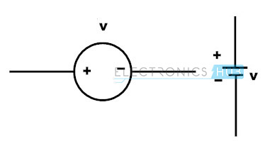](https://www.electronicshub.org/wp-content/uploads/2015/02/voltage-symbols.jpg)

#### Electric Current

It is the flow of electrons or electric charge. It is measured in Amperes or simply Amps, and denoted by the letter ‘I’ or lower case i. This electric current can be direct or alternating. The Direct Current (DC) flows in a unidirectional way and generally it is produced by batteries, solar cells, thermocouples, etc. In case of AC, electric charge movement periodically changes as we can observe in case of sine wave.

[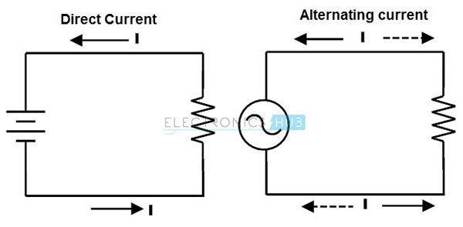](https://www.electronicshub.org/wp-content/uploads/2015/02/4.Electric-Current.jpg)

Generally in circuits the direction of current flow is indicated with a letter I or lower case I with an arrow associated with it. But this direction actually indicates the conventional current flow rather than actual electron current flow.

#### Difference Between Conventional and Electron Current Flow

Electrons flow from negative terminal to positive terminal is referred as electron current flow, whereas from positive terminal to the negative terminal is referred as conventional current flow as shown in figure.

The electrons have always been repelled by the negative charge where the terminal is connected to the negative terminal of the battery and are attracted at positive terminal due to the positive charge. Hence the electrons flow from negative terminal to positive terminal is referred as electron current flow. But conventional method of assuming current flow is from positive to negative so this is referred as conventional current flow. Conventional current is indicated on many circuit diagrams and actual electron flow current is indicated in the case of describing the individual current flow.

The conventional current flow is due to the positive charge carriers. The conventional current is measured in the opposite direction of actual electron current flow, which is due to the negative charge carriers (Electrons) therefore, conventional current is always positive. It is also measured in Amps.

The difference of conventional and actual electron flow does not effect on any computational results and real time behavior. Most of the analyzing concepts of DC circuit results are independent of the direction of current flow. However, the conventional current is the standard and mostly follows.

#### Resistance

The resistance of a conducting material opposes the flow of electrons. It is measured in ohms and denoted by the Greek symbol **Ω.**  Depends on the resistor value in a circuit voltage applied to the circuit is decided. Thus, resistance can be defined as the voltage required for a circuit for making 1 ampere current flow. This also referred as Ohm’s law and written as R = V/I. That means if a circuit requires 200V to produce 2A current then the resistance should be 100 ohms. The resistance value is always positive. Resistors can be fixed or variable resistors as shown in figure.

[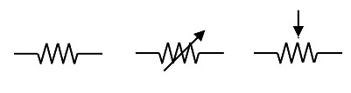](https://www.electronicshub.org/wp-content/uploads/2015/02/6.Resistance.jpg)

#### Electric power (P) and Energy

 The power is termed as the work done in a given amount of time. In electrical circuits, power is exactly equal to the product of voltage and current. Since the voltage is the work per unit charge and current is the rate at which electrons move in a circuit. The Power is measured in **watts (W)** and its formula is

**P = I x V**

According to Ohms law,

R = V/I

V= IR

Substituting in the above equation,

P = (IR) R

**P = I2R**

Or also, by substituting I = V/R, we can get

P= V x (V/R)

**P= V2/R**

Number System

The technique to represent and work with numbers is called **number system**. **Decimal number system** is the most common number system. Other popular number systems include **binary number system, octal number system, hexadecimal number system,** etc.

**Decimal Number System**

Decimal number system is a **base 10** number system having 10 digits from 0 to 9. This means that any numerical quantity can be represented using these 10 digits. Decimal number system is also a **positional value system**. This means that the value of digits will depend on its position. Let us take an example to understand this.

Say we have three numbers – 734, 971 and 207. The value of 7 in all three numbers is different−

* In 734, value of 7 is 7 hundreds or 700 or 7 × 100 or 7 × 102
* In 971, value of 7 is 7 tens or 70 or 7 × 10 or 7 × 101
* In 207, value 0f 7 is 7 units or 7 or 7 × 1 or 7 × 100

The weightage of each position can be represented as follows −

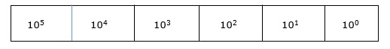

In digital systems, instructions are given through electric signals; variation is done by varying the voltage of the signal. Having 10 different voltages to implement decimal number system in digital equipment is difficult. So, many number systems that are easier to implement digitally have been developed. Let’s look at them in detail.

**Binary Number System**

The easiest way to vary instructions through electric signals is two-state system – on and off. On is represented as 1 and off as 0, though 0 is not actually no signal but signal at a lower voltage. The number system having just these two digits – 0 and 1 – is called **binary number system**.

Each binary digit is also called a **bit**. Binary number system is also positional value system, where each digit has a value expressed in powers of 2, as displayed here.

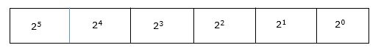

In any binary number, the rightmost digit is called **least significant bit (LSB)** and leftmost digit is called **most significant bit (MSB)**.

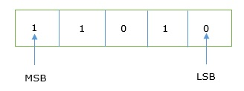

And decimal equivalent of this number is sum of product of each digit with its positional value.

110102 = 1×24 + 1×23 + 0×22 + 1×21 + 0×20

= 16 + 8 + 0 + 2 + 0

= 2610

Computer memory is measured in terms of how many bits it can store. Here is a chart for memory capacity conversion.

* 1 byte (B) = 8 bits
* 1 Kilobytes (KB) = 1024 bytes
* 1 Megabyte (MB) = 1024 KB
* 1 Gigabyte (GB) = 1024 MB
* 1 Terabyte (TB) = 1024 GB
* 1 Exabyte (EB) = 1024 PB
* 1 Zettabyte = 1024 EB
* 1 Yottabyte (YB) = 1024 ZB

**Octal Number System**

**Octal number system** has eight digits – 0, 1, 2, 3, 4, 5, 6 and 7. Octal number system is also a positional value system with where each digit has its value expressed in powers of 8, as shown here −

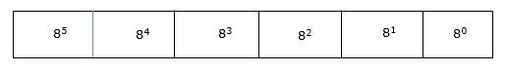

Decimal equivalent of any octal number is sum of product of each digit with its positional value.

7268 = 7×82 + 2×81 + 6×80

= 448 + 16 + 6

= 47010

**Hexadecimal Number System**

**Octal number system** has 16 symbols – 0 to 9 and A to F where A is equal to 10, B is equal to 11 and so on till F. Hexadecimal number system is also a positional value system with where each digit has its value expressed in powers of 16, as shown here −

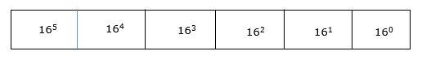

Decimal equivalent of any hexadecimal number is sum of product of each digit with its positional value.

27FB16 = 2×163 + 7×162 + 15×161 + 10×160

= 8192 + 1792 + 240 +10

= 1023410

**Number System Relationship**

The following table depicts the relationship between decimal, binary, octal and hexadecimal number systems.

|  |  |  |  |
| --- | --- | --- | --- |
| **HEXADECIMAL** | **DECIMAL** | **OCTAL** | **BINARY** |
| 0 | 0 | 0 | 0000 |
| 1 | 1 | 1 | 0001 |
| 2 | 2 | 2 | 0010 |
| 3 | 3 | 3 | 0011 |
| 4 | 4 | 4 | 0100 |
| 5 | 5 | 5 | 0101 |
| 6 | 6 | 6 | 0110 |
| 7 | 7 | 7 | 0111 |
| 8 | 8 | 10 | 1000 |
| 9 | 9 | 11 | 1001 |
| A | 10 | 12 | 1010 |
| B | 11 | 13 | 1011 |
| C | 12 | 14 | 1100 |
| D | 13 | 15 | 1101 |
| E | 14 | 16 | 1110 |
| F | 15 | 17 | 1111 |

**ASCII**

Besides numerical data, computer must be able to handle alphabets, punctuation marks, mathematical operators, special symbols, etc. that form the complete character set of English language. The complete set of characters or symbols are called alphanumeric codes. The complete alphanumeric code typically includes −

* 26 upper case letters
* 26 lower case letters
* 10 digits
* 7 punctuation marks
* 20 to 40 special characters

Now a computer understands only numeric values, whatever the number system used. So all characters must have a numeric equivalent called the alphanumeric code. The most widely used alphanumeric code is American Standard Code for Information Interchange (ASCII). ASCII is a 7-bit code that has 128 (27) possible codes.

As you know decimal, binary, octal and hexadecimal number systems are positional value number systems. To convert binary, octal and hexadecimal to decimal number, we just need to add the product of each digit with its positional value. Here we are going to learn other conversion among these number systems.

**Decimal to Binary**

Decimal numbers can be converted to binary by repeated division of the number by 2 while recording the remainder. Let’s take an example to see how this happens.

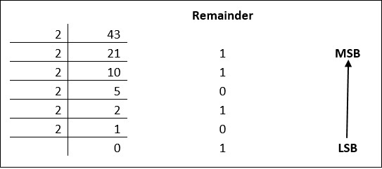

The remainders are to be read from bottom to top to obtain the binary equivalent.

4310 = 1010112

**Decimal to Octal**

Decimal numbers can be converted to octal by repeated division of the number by 8 while recording the remainder. Let’s take an example to see how this happens.

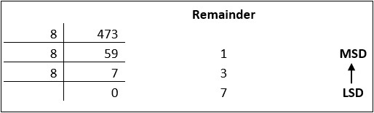

Reading the remainders from bottom to top,

47310 = 7318

**Decimal to Hexadecimal**

Decimal numbers can be converted to octal by repeated division of the number by 16 while recording the remainder. Let’s take an example to see how this happens.

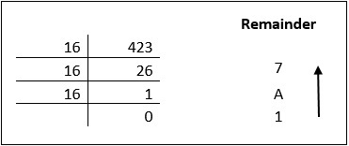

Reading the remainders from bottom to top we get,

42310 = 1A716

**Binary to Octal and Vice Versa**

To convert a binary number to octal number, these steps are followed −

* Starting from the least significant bit, make groups of three bits.
* If there are one or two bits less in making the groups, 0s can be added after the most significant bit
* Convert each group into its equivalent octal number

Let’s take an example to understand this.

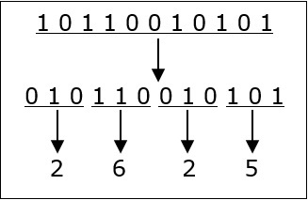

101100101012 = 26258

To convert an octal number to binary, each octal digit is converted to its 3-bit binary equivalent according to this table.

|  |  |  |  |  |  |  |  |  |
| --- | --- | --- | --- | --- | --- | --- | --- | --- |
| Octal Digit | 0 | 1 | 2 | 3 | 4 | 5 | 6 | 7 |
| Binary Equivalent | 000 | 001 | 010 | 011 | 100 | 101 | 110 | 111 |

546738 = 1011001101110112

**Binary to Hexadecimal**

To convert a binary number to hexadecimal number, these steps are followed −

* Starting from the least significant bit, make groups of four bits.
* If there are one or two bits less in making the groups, 0s can be added after the most significant bit.
* Convert each group into its equivalent octal number.

Let’s take an example to understand this.

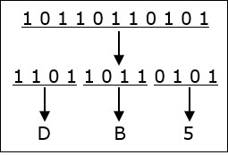

101101101012 = DB516

To convert an octal number to binary, each octal digit is converted to its 3-bit binary equivalent.

Number System

The technique to represent and work with numbers is called **number system**. **Decimal number system** is the most common number system. Other popular number systems include **binary number system, octal number system, hexadecimal number system,** etc.

**Decimal Number System**

Decimal number system is a **base 10** number system having 10 digits from 0 to 9. This means that any numerical quantity can be represented using these 10 digits. Decimal number system is also a **positional value system**. This means that the value of digits will depend on its position. Let us take an example to understand this.

Say we have three numbers – 734, 971 and 207. The value of 7 in all three numbers is different−

* In 734, value of 7 is 7 hundreds or 700 or 7 × 100 or 7 × 102
* In 971, value of 7 is 7 tens or 70 or 7 × 10 or 7 × 101
* In 207, value 0f 7 is 7 units or 7 or 7 × 1 or 7 × 100

The weightage of each position can be represented as follows −



In digital systems, instructions are given through electric signals; variation is done by varying the voltage of the signal. Having 10 different voltages to implement decimal number system in digital equipment is difficult. So, many number systems that are easier to implement digitally have been developed. Let’s look at them in detail.

**Binary Number System**

The easiest way to vary instructions through electric signals is two-state system – on and off. On is represented as 1 and off as 0, though 0 is not actually no signal but signal at a lower voltage. The number system having just these two digits – 0 and 1 – is called **binary number system**.

Each binary digit is also called a **bit**. Binary number system is also positional value system, where each digit has a value expressed in powers of 2, as displayed here.



In any binary number, the rightmost digit is called **least significant bit (LSB)** and leftmost digit is called **most significant bit (MSB)**.



And decimal equivalent of this number is sum of product of each digit with its positional value.

110102 = 1×24 + 1×23 + 0×22 + 1×21 + 0×20

= 16 + 8 + 0 + 2 + 0

= 2610

Computer memory is measured in terms of how many bits it can store. Here is a chart for memory capacity conversion.

* 1 byte (B) = 8 bits
* 1 Kilobytes (KB) = 1024 bytes
* 1 Megabyte (MB) = 1024 KB
* 1 Gigabyte (GB) = 1024 MB
* 1 Terabyte (TB) = 1024 GB
* 1 Exabyte (EB) = 1024 PB
* 1 Zettabyte = 1024 EB
* 1 Yottabyte (YB) = 1024 ZB

**Octal Number System**

**Octal number system** has eight digits – 0, 1, 2, 3, 4, 5, 6 and 7. Octal number system is also a positional value system with where each digit has its value expressed in powers of 8, as shown here −



Decimal equivalent of any octal number is sum of product of each digit with its positional value.

7268 = 7×82 + 2×81 + 6×80

= 448 + 16 + 6

= 47010

**Hexadecimal Number System**

**Octal number system** has 16 symbols – 0 to 9 and A to F where A is equal to 10, B is equal to 11 and so on till F. Hexadecimal number system is also a positional value system with where each digit has its value expressed in powers of 16, as shown here −



Decimal equivalent of any hexadecimal number is sum of product of each digit with its positional value.

27FB16 = 2×163 + 7×162 + 15×161 + 10×160

= 8192 + 1792 + 240 +10

= 1023410

**Number System Relationship**

The following table depicts the relationship between decimal, binary, octal and hexadecimal number systems.

|  |  |  |  |
| --- | --- | --- | --- |
| **HEXADECIMAL** | **DECIMAL** | **OCTAL** | **BINARY** |
| 0 | 0 | 0 | 0000 |
| 1 | 1 | 1 | 0001 |
| 2 | 2 | 2 | 0010 |
| 3 | 3 | 3 | 0011 |
| 4 | 4 | 4 | 0100 |
| 5 | 5 | 5 | 0101 |
| 6 | 6 | 6 | 0110 |
| 7 | 7 | 7 | 0111 |
| 8 | 8 | 10 | 1000 |
| 9 | 9 | 11 | 1001 |
| A | 10 | 12 | 1010 |
| B | 11 | 13 | 1011 |
| C | 12 | 14 | 1100 |
| D | 13 | 15 | 1101 |
| E | 14 | 16 | 1110 |
| F | 15 | 17 | 1111 |

**ASCII**

Besides numerical data, computer must be able to handle alphabets, punctuation marks, mathematical operators, special symbols, etc. that form the complete character set of English language. The complete set of characters or symbols are called alphanumeric codes. The complete alphanumeric code typically includes −

* 26 upper case letters
* 26 lower case letters
* 10 digits
* 7 punctuation marks
* 20 to 40 special characters

Now a computer understands only numeric values, whatever the number system used. So all characters must have a numeric equivalent called the alphanumeric code. The most widely used alphanumeric code is American Standard Code for Information Interchange (ASCII). ASCII is a 7-bit code that has 128 (27) possible codes.

As you know decimal, binary, octal and hexadecimal number systems are positional value number systems. To convert binary, octal and hexadecimal to decimal number, we just need to add the product of each digit with its positional value. Here we are going to learn other conversion among these number systems.

**Decimal to Binary**

Decimal numbers can be converted to binary by repeated division of the number by 2 while recording the remainder. Let’s take an example to see how this happens.



The remainders are to be read from bottom to top to obtain the binary equivalent.

4310 = 1010112

**Decimal to Octal**

Decimal numbers can be converted to octal by repeated division of the number by 8 while recording the remainder. Let’s take an example to see how this happens.



Reading the remainders from bottom to top,

47310 = 7318

**Decimal to Hexadecimal**

Decimal numbers can be converted to octal by repeated division of the number by 16 while recording the remainder. Let’s take an example to see how this happens.



Reading the remainders from bottom to top we get,

42310 = 1A716

**Binary to Octal and Vice Versa**

To convert a binary number to octal number, these steps are followed −

* Starting from the least significant bit, make groups of three bits.
* If there are one or two bits less in making the groups, 0s can be added after the most significant bit
* Convert each group into its equivalent octal number

Let’s take an example to understand this.



101100101012 = 26258

To convert an octal number to binary, each octal digit is converted to its 3-bit binary equivalent according to this table.

|  |  |  |  |  |  |  |  |  |
| --- | --- | --- | --- | --- | --- | --- | --- | --- |
| Octal Digit | 0 | 1 | 2 | 3 | 4 | 5 | 6 | 7 |
| Binary Equivalent | 000 | 001 | 010 | 011 | 100 | 101 | 110 | 111 |

546738 = 1011001101110112

**Binary to Hexadecimal**

To convert a binary number to hexadecimal number, these steps are followed −

* Starting from the least significant bit, make groups of four bits.
* If there are one or two bits less in making the groups, 0s can be added after the most significant bit.
* Convert each group into its equivalent octal number.

Let’s take an example to understand this.



101101101012 = DB516

To convert an octal number to binary, each octal digit is converted to its 3-bit binary equivalent.

**Binary Codes**

In the coding, when numbers, letters or words are represented by a specific group of symbols, it is said that the number, letter or word is being encoded. The group of symbols is called as a code. The digital data is represented, stored and transmitted as group of binary bits. This group is also called as **binary code**. The binary code is represented by the number as well as alphanumeric letter.

**Advantages of Binary Code**

Following is the list of advantages that binary code offers.

* Binary codes are suitable for the computer applications.
* Binary codes are suitable for the digital communications.
* Binary codes make the analysis and designing of digital circuits if we use the binary codes.
* Since only 0 & 1 are being used, implementation becomes easy.

**Classification of binary codes**

The codes are broadly categorized into following four categories.

* Weighted Codes
* Non-Weighted Codes
* Binary Coded Decimal Code
* Alphanumeric Codes
* Error Detecting Codes
* Error Correcting Codes

**Weighted Codes**

Weighted binary codes are those binary codes which obey the positional weight principle. Each position of the number represents a specific weight. Several systems of the codes are used to express the decimal digits 0 through 9. In these codes each decimal digit is represented by a group of four bits.

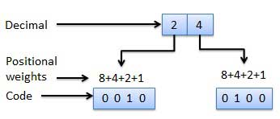

**Non-Weighted Codes**

In this type of binary codes, the positional weights are not assigned. The examples of non-weighted codes are Excess-3 code and Gray code.

**Excess-3 code**

The Excess-3 code is also called as XS-3 code. It is non-weighted code used to express decimal numbers. The Excess-3 code words are derived from the 8421 BCD code words adding (0011)2 or (3)10 to each code word in 8421. The excess-3 codes are obtained as follows −

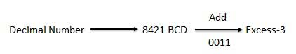

**Example**

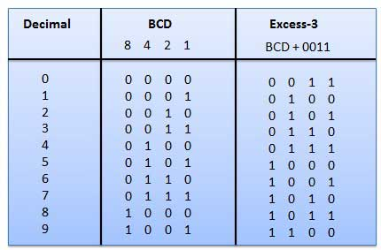

**Gray Code**

It is the non-weighted code and it is not arithmetic codes. That means there are no specific weights assigned to the bit position. It has a very special feature that, only one bit will change each time the decimal number is incremented as shown in fig. As only one bit changes at a time, the gray code is called as a unit distance code. The gray code is a cyclic code. Gray code cannot be used for arithmetic operation.

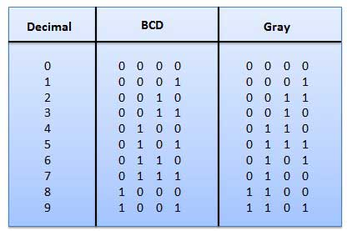

**Application of Gray code**

* Gray code is popularly used in the shaft position encoders.
* A shaft position encoder produces a code word which represents the angular position of the shaft.

**Binary Coded Decimal (BCD) code**

In this code each decimal digit is represented by a 4-bit binary number. BCD is a way to express each of the decimal digits with a binary code. In the BCD, with four bits we can represent sixteen numbers (0000 to 1111). But in BCD code only first ten of these are used (0000 to 1001). The remaining six code combinations i.e. 1010 to 1111 are invalid in BCD.

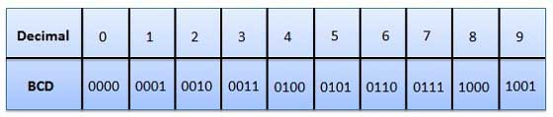

**Advantages of BCD Codes**

* It is very similar to decimal system.
* We need to remember binary equivalent of decimal numbers 0 to 9 only.

**Disadvantages of BCD Codes**

* The addition and subtraction of BCD have different rules.
* The BCD arithmetic is little more complicated.
* BCD needs more number of bits than binary to represent the decimal number. So BCD is less efficient than binary.

**Alphanumeric codes**

A binary digit or bit can represent only two symbols as it has only two states '0' or '1'. But this is not enough for communication between two computers because there we need many more symbols for communication. These symbols are required to represent 26 alphabets with capital and small letters, numbers from 0 to 9, punctuation marks and other symbols.

The alphanumeric codes are the codes that represent numbers and alphabetic characters. Mostly such codes also represent other characters such as symbol and various instructions necessary for conveying information. An alphanumeric code should at least represent 10 digits and 26 letters of alphabet i.e. total 36 items. The following three alphanumeric codes are very commonly used for the data representation.

* American Standard Code for Information Interchange (ASCII).
* Extended Binary Coded Decimal Interchange Code (EBCDIC).
* Five bit Baudot Code.

ASCII code is a 7-bit code whereas EBCDIC is an 8-bit code. ASCII code is more commonly used worldwide while EBCDIC is used primarily in large IBM computers.

**Error Codes**

There are binary code techniques available to detect and correct data during data transmission.

|  |  |
| --- | --- |
| **Error Code** | **Description** |

**Electronic Components**

Now its time to talk about the different components that make your electronic projects come to life.  Below is a quick breakdown of the most common components and functions they perform.

**Switch**

Switches can come in many forms such as pushbutton, rocker, momentary and others.  Their basic function is to interrupt electric current by turning a circuit on or off.

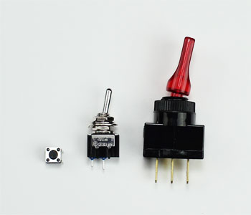

**Resistor**

Resistors are used to resist the flow of current or to control the voltage in a circuit.  The amount of resistance that a resistor offers is measured in Ohms.  Most resistors have colored stripes on the outside and this code will tell you it’s value of resistance.  You can use a multimeter or Digikey’s [resistor color code calculator](http://www.digikey.com/en/resources/conversion-calculators/conversion-calculator-resistor-color-code-4-band) to determine the value of a resistor.

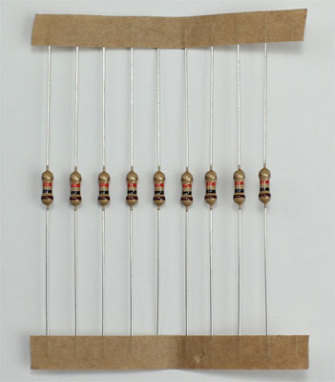

**Variable Resistor (Potentiometer)**

A variable resistor is also known as a potentiometer.  These components can be found in devices such as a light dimmer or volume control for a radio.   When you turn the shaft of a potentiometer the resistance changes in the circuit.

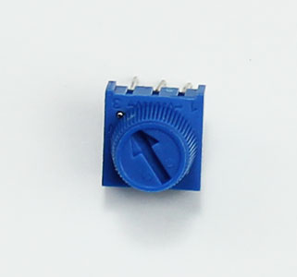

**Light-Dependent Resistor (LDR)**

A light-dependent resistor is also a variable resistor but is controlled by the light versus turning a knob.  The resistance in the circuit changes with the intensity of the light.  These are often found in exterior lights that automatically turn on at dusk and off at dawn.

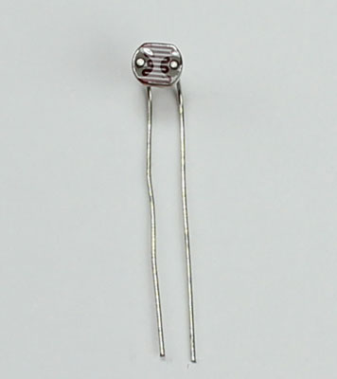

**Capacitor**

Capacitors store electricity and then discharges it back into the circuit when there is a drop in voltage.  A capacitor is like a rechargeable battery and can be charged and then discharged.  The value is measured in F (Farad), nano Farad (nF) or pico Farad (pF) range.

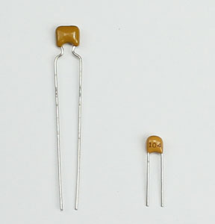

**Diode**

A diode allows electricity to flow in one direction and blocks it from flowing the opposite way.  The diode’s primary role is to route electricity from taking an unwanted path within the circuit.

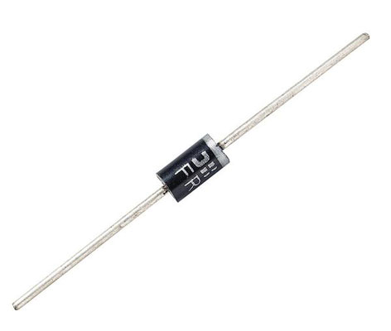

**Light-Emitting Diode (LED)**

A light-emitting diode is like a standard diode in the fact that electrical current only flows in one direction.  The main difference is an LED will emit light when electricity flows through it.  Inside an LED there is an anode and cathode.  Current always flows from the anode (+) to the cathode (-) and never in the opposite direction.  The longer leg of the LED is the positive (anode) side.

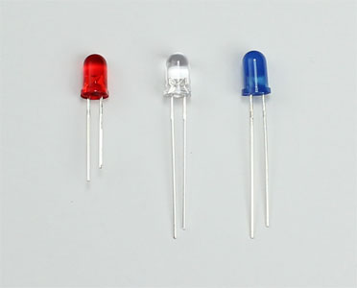

**Transistor**

Transistor are tiny switches that turn a current on or off when triggered by an electric signal.  In addition to being a switch, it can also be used to amplify electronic signals.  A transistor is similar to a relay except with no moving parts.

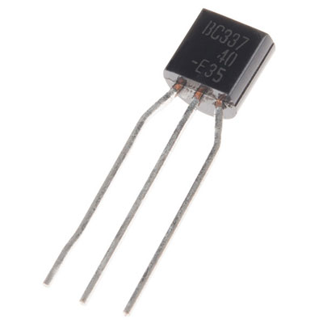

**Relay**

A relay is an electrically operated switch that opens or closes when power is applied.  Inside a relay is an electromagnet which controls a mechanical switch.

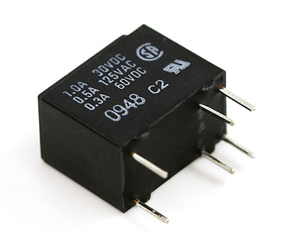

**Integrated Circuit (IC)**

An integrated circuit is a circuit that’s been reduced in size to fit inside a tiny chip.  This circuit contains electronic components like resistors and capacitors but on a much smaller scale.  Integrated circuits come in different variations such as 555 timers, voltage regulators, microcontrollers and many more.  Each pin on an IC is unique in terms of it’s function.

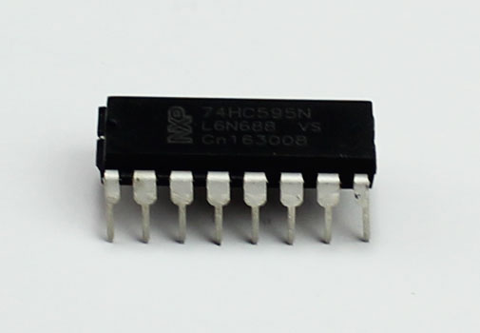

**What Is A Circuit?**

Before you design an electronic project, you need to know what a circuit is and how to create one properly.

An electronic circuit is a circular path of conductors by which electric current can flow.  A closed circuit is like a circle because it starts and ends at the same point forming a complete loop. Furthermore, a closed circuit allows electricity to flow from the (+) power to the (-) ground uninterrupted.

In contrast, if there is any break in the flow of electricity, this is known as an open circuit.  As shown below, a switch in a circuit can cause it to be open or closed depending on it’s position.

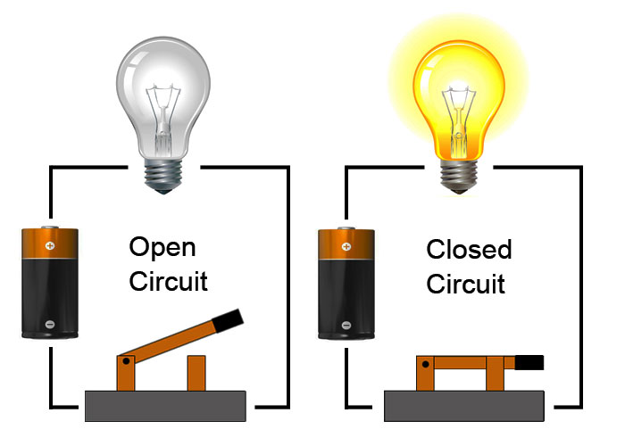

All circuits need to have three basic elements.  These elements are a voltage source, conductive path and a load.

The voltage source, such as a battery, is needed in order to cause the current to flow through the circuit.  In addition, there needs to be a conductive path that provides a route for the electricity to flow.  Finally, a proper circuit needs a load that consumes the power.  The load in the above circuit is the light bulb.

**Semiconductor Theory: Definition & Fundamentals**

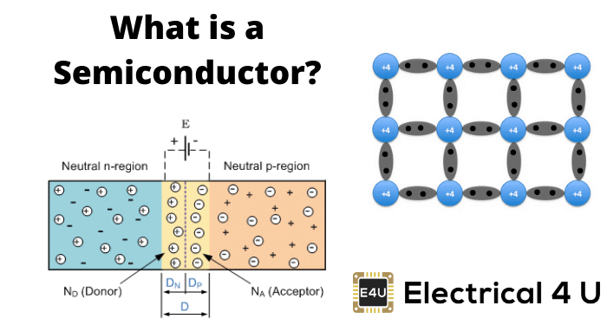

We can classify materials by the energy gap between their valence band and the conduction band. The valence band is the band consisting of the valence electron, and the conduction band remains empty. Conduction takes place when an electron jumps from valence band to conduction band, and the gap between these two bands is forbidden energy gap.

A wider the gap between the valence and conduction bands, higher the energy it requires for shifting an electron from valence band to the conduction band. In the case of [conductors](https://www.electrical4u.com/electrical-conductor/), this energy gap is absent or in other words conduction band, and valence band overlaps each other. Thus, electron requires minimum energy to jump from valence band. The typical examples of conductors are Silver, Copper, and Aluminium. In [insulators](https://www.electrical4u.com/electrical-insulator-insulating-material-porcelain-glass-polymer-insulator/), this gap is vast.

Therefore, it requires a significant amount of energy to shift an electron from valence to conduction band. Thus, insulators are poor conductors of electricity. Mica and Ceramic are the well-known examples of insulation material. **Semiconductors**, on the other hand, have an energy gap which is in between that of conductors and insulators.

This gap is typically more or less 1 eV, and thus, one electron requires energy more than conductors but less than insulating materials for shifting valence band to conduction band. At low temperature there are very less number of electrons in conduction band in a semiconductor crystal but when the temperature is increased more and more electrons get sufficient energy to migrate from valence band to conduction band. Because of that, they don’t conduct electricity at low temperature but as the temperature increases the conductivity increases. The most typical examples of the semiconductors are silicon and germanium.

**Definition of Semiconductor**

Thus, the **definition of semiconductor** can be as follows.

The materials that are neither conductor nor insulator with energy gap of about 1 eV (electron volt) are called semiconductors.

Most common materials commercially used as semiconductors are germanium (Ge) and silicon (Si) because of their property to withstand high temperature. That means there will be no significant change in energy gap with changing temperature.

The relation between energy gap and absolute temperature for Si and Ge are given as,  
  
Where, T = absolute temperature in oK  
Assuming room temperature to be 300oK,

At room temperature [resistivity](https://www.electrical4u.com/electrical-resistance-and-laws-of-resistance/) of semiconductor is in between insulators and conductors. Semiconductors show negative temperature coefficient of resistivity that means its [resistance](https://www.electrical4u.com/electrical-resistance-and-laws-of-resistance/) decreases with increase in temperature. Both Si and Ge are elements of IV group, i.e. both elements have four valence electrons. Both form the covalent bond with the neighboring [atom](https://www.electrical4u.com/concept-of-atom/). At absolute zero temperature both behave like an insulator, i.e. the valence band is full while conduction band is empty but as the temperature is raised more and more covalent bonds break and electrons are set free and jump to the conduction band.  
  
In the above energy band diagrams of a semiconductor. CB is the conduction band, and VB is the valence band. At 0oK, the VB is full with all the valence electrons.

**Intrinsic Semiconductors**

As per **theory of semiconductor**, semiconductor in its pure form is called as [intrinsic semiconductor](https://www.electrical4u.com/intrinsic-silicon-and-extrinsic-silicon/). In pure semiconductor number of electrons (n) is equal to number of holes (p) and thus conductivity is very low as valence electrons are covalent bonded. In this case we write n = p = ni, where ni is called the intrinsic concentration. It can be shown that ni can be written  
Where, n0 is a constant, T is the absolute temperature, VG is the semiconductor band gap voltage, and VT is the thermal voltage.  
The thermal [voltage](https://www.electrical4u.com/voltage-or-electric-potential-difference/) is related to the temperature by VT = kT/q  
Where, k is the Boltzmann constant (k = 1.381 × 10 − 23 J/K).  
In **intrinsic semiconductors** conductivity (σ) is determined by both electrons (σe) and holes (σh) and depends on the carrier density.  
σe = neμe, σh = peμh  
Conductivity,  
Where n, p = numbers of electrons and holes respectively.  
μh, μe = mobility of free holes and electrons respectively  
N = n = p  
e = charge on carrier

**Extrinsic Semiconductors**

As per **theory of semiconductor**, impure semiconductors are called [extrinsic semiconductors](https://www.electrical4u.com/intrinsic-silicon-and-extrinsic-silicon/). **Extrinsic semiconductor** is formed by adding a small amount of impurity. Depending on the type of impurity added we have two types of semiconductors: N-type and [P-type semiconductors](https://www.electrical4u.com/p-type-semiconductor/). In 100 million parts of semiconductor one part of impurity is added.

**N type Semiconductor**

In this type of semiconductor majority carriers are electrons and minority carriers are holes. [N – type semiconductor](https://www.electrical4u.com/n-type-semiconductor/) is formed by adding pentavalent (five valence electrons) impurity in pure semiconductor crystal, e.g. P. As, Sb.  
  
Four of the five valence electron of pentavalent impurity forms covalent bond with Si atom and the remaining electron is free to move anywhere within the crystal. Pentavalent impurity donates electron to Si that’s why N-type impurity atoms are known as donor atoms. This enhances the conductivity of pure Si. Majority carriers are electrons therefore conductivitry is due to these electrons only and is given by,  
σ = neμe

**P type Semiconductors**

In this type of semiconductor majority carriers are holes, and minority carriers are electrons. The p-type semiconductor is formed by adding trivalent ( three valence electrons) impurity in a pure semiconductor crystal, e.g. B, Al Ba.  
  
Three of the four valence electron of tetravalent impurity forms covalent bonds with Si atoms. The phenomenon creates a space which we refer to a hole. When the temperature rises an electron from another covalent bond jumps to fill this space. Hence, a hole gets created behind. In this way conduction takes place. P-type impurity accepts electrons and is called acceptor atom. Majority carriers are holes, and therefore conductivity is due to these holes only and is given by,  
σ = neμh

**Memory**

A memory is just like a human brain. It is used to store data and instruction. Computer memory is the storage space in computer where data is to be processed and instructions required for processing are stored.

The memory is divided into large number of small parts. Each part is called a cell. Each location or cell has a unique address which varies from zero to memory size minus one.

For example if computer has 64k words, then this memory unit has 64 * 1024 = 65536 memory location. The address of these locations varies from 0 to 65535.

Memory is primarily of two types

* **Internal Memory** − cache memory and primary/main memory
* **External Memory** − magnetic disk / optical disk etc.

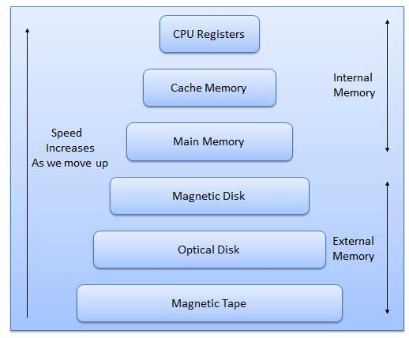

Characteristics of Memory Hierarchy are following when we go from top to bottom.

* Capacity in terms of storage increases.
* Cost per bit of storage decreases.
* Frequency of access of the memory by the CPU decreases.
* Access time by the CPU increases.

**RAM**

A RAM constitutes the internal memory of the CPU for storing data, program and program result. It is read/write memory. It is called random access memory (RAM).

Since access time in RAM is independent of the address to the word that is, each storage location inside the memory is as easy to reach as other location & takes the same amount of time. We can reach into the memory at random & extremely fast but can also be quite expensive.

RAM is volatile, i.e. data stored in it is lost when we switch off the computer or if there is a power failure. Hence, a backup uninterruptible power system (UPS) is often used with computers. RAM is small, both in terms of its physical size and in the amount of data it can hold.

RAM is of two types

* Static RAM (SRAM)
* Dynamic RAM (DRAM)

**Static RAM (SRAM)**

The word **static** indicates that the memory retains its contents as long as power remains applied. However, data is lost when the power gets down due to volatile nature. SRAM chips use a matrix of 6-transistors and no capacitors. Transistors do not require power to prevent leakage, so SRAM need not have to be refreshed on a regular basis.

Because of the extra space in the matrix, SRAM uses more chips than DRAM for the same amount of storage space, thus making the manufacturing costs higher.

Static RAM is used as cache memory needs to be very fast and small.

**Dynamic RAM (DRAM)**

DRAM, unlike SRAM, must be continually **refreshed** in order for it to maintain the data. This is done by placing the memory on a refresh circuit that rewrites the data several hundred times per second. DRAM is used for most system memory because it is cheap and small. All DRAMs are made up of memory cells. These cells are composed of one capacitor and one transistor.

**ROM**

ROM stands for Read Only Memory. The memory from which we can only read but cannot write on it. This type of memory is non-volatile. The information is stored permanently in such memories during manufacture.

A ROM, stores such instruction as are required to start computer when electricity is first turned on, this operation is referred to as bootstrap. ROM chip are not only used in the computer but also in other electronic items like washing machine and microwave oven.

Following are the various types of ROM −

**MROM (Masked ROM)**

The very first ROMs were hard-wired devices that contained a pre-programmed set of data or instructions. These kind of ROMs are known as masked ROMs. It is inexpensive ROM.

**PROM (Programmable Read Only Memory)**

PROM is read-only memory that can be modified only once by a user. The user buys a blank PROM and enters the desired contents using a PROM programmer. Inside the PROM chip there are small fuses which are burnt open during programming. It can be programmed only once and is not erasable.

**EPROM (Erasable and Programmable Read Only Memory)**

The EPROM can be erased by exposing it to ultra-violet light for a duration of upto 40 minutes. Usually, an EPROM eraser achieves this function. During programming an electrical charge is trapped in an insulated gate region. The charge is retained for more than ten years because the charge has no leakage path. For erasing this charge, ultra-violet light is passed through a quartz crystal window (lid). This exposure to ultra-violet light dissipates the charge. During normal use the quartz lid is sealed with a sticker.

**EEPROM (Electrically Erasable and Programmable Read Only Memory)**

The EEPROM is programmed and erased electrically. It can be erased and reprogrammed about ten thousand times. Both erasing and programming take about 4 to 10 ms (millisecond). In EEPROM, any location can be selectively erased and programmed. EEPROMs can be erased one byte at a time, rather than erasing the entire chip. Hence, the process of re-programming is flexible but slow.

**Serial Access Memory**

Sequential access means the system must search the storage device from the beginning of the memory address until it finds the required piece of data. Memory device which supports such access is called a Sequential Access Memory or Serial Access Memory. Magnetic tape is an example of serial access memory.

**Direct Access Memory**

Direct access memory or Random Access Memory, refers to conditions in which a system can go directly to the information that the user wants. Memory device which supports such access is called a Direct Access Memory. Magnetic disks, optical disks are examples of direct access memory.

**Cache Memory**

Cache memory is a very high speed semiconductor memory which can speed up CPU. It acts as a buffer between the CPU and main memory. It is used to hold those parts of data and program which are most frequently used by CPU. The parts of data and programs, are transferred from disk to cache memory by operating system, from where CPU can access them.

**Advantages**

* Cache memory is faster than main memory.
* It consumes less access time as compared to main memory.
* It stores the program that can be executed within a short period of time.
* It stores data for temporary use.

**Disadvantages**

* Cache memory has limited capacity.
* It is very expensive.

Virtual memory is a technique that allows the execution of processes which are not completely available in memory. The main visible advantage of this scheme is that programs can be larger than physical memory. Virtual memory is the separation of user logical memory from physical memory.

This separation allows an extremely large virtual memory to be provided for programmers when only a smaller physical memory is available. Following are the situations, when entire program is not required to be loaded fully in main memory.

* User written error handling routines are used only when an error occurred in the data or computation.
* Certain options and features of a program may be used rarely.
* Many tables are assigned a fixed amount of address space even though only a small amount of the table is actually used.
* The ability to execute a program that is only partially in memory would counter many benefits.
* Less number of I/O would be needed to load or swap each user program into memory.
* A program would no longer be constrained by the amount of physical memory that is available.
* Each user program could take less physical memory, more programs could be run the same time, with a corresponding increase in CPU utilization and throughput.

**Auxiliary Memory**

Auxiliary memory is much larger in size than main memory but is slower. It normally stores system programs, instruction and data files. It is also known as secondary memory. It can also be used as an overflow/virtual memory in case the main memory capacity has been exceeded. Secondary memories cannot be accessed directly by a processor. First the data/information of auxiliary memory is transferred to the main memory and then that information can be accessed by the CPU. Characteristics of Auxiliary Memory are following −

* **Non-volatile memory** − Data is not lost when power is cut off.
* **Reusable** − The data stays in the secondary storage on permanent basis until it is not overwritten or deleted by the user.
* **Reliable** − Data in secondary storage is safe because of high physical stability of secondary storage device.
* **Convenience** − With the help of a computer software, authorised people can locate and access the data quickly.
* **Capacity** − Secondary storage can store large volumes of data in sets of multiple disks.
* **Cost** − It is much lesser expensive to store data on a tape or disk than primary memory.

LOGIC GATES AND COMBINATIONAL LOGIC CIRCUIT

Logic gates are the basic building blocks of any digital system. It is an electronic circuit having one or more than one input and only one output. The relationship between the input and the output is based on a **certain logic**. Based on this, logic gates are named as AND gate, OR gate, NOT gate etc.

**AND Gate**

A circuit which performs an AND operation is shown in figure. It has n input (n >= 2) and one output.

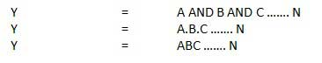

**Logic diagram**

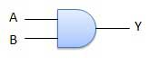

**Truth Table**

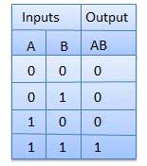

**OR Gate**

A circuit which performs an OR operation is shown in figure. It has n input (n >= 2) and one output.

OR gate

**Logic diagram**

OR Logical Diagram

**Truth Table**

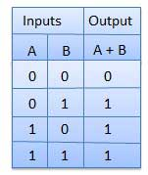

**NOT Gate**

NOT gate is also known as **Inverter**. It has one input A and one output Y.

NOT gate

**Logic diagram**

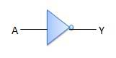

**Truth Table**

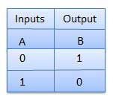

**NAND Gate**

A NOT-AND operation is known as NAND operation. It has n input (n >= 2) and one output.

NAND gate

**Logic diagram**

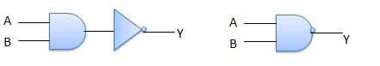

**Truth Table**

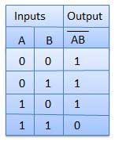

**NOR Gate**

A NOT-OR operation is known as NOR operation. It has n input (n >= 2) and one output.

NOR gate

**Logic diagram**

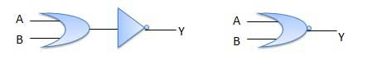

**Truth Table**

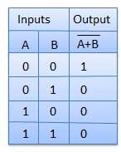

**XOR Gate**

XOR or Ex-OR gate is a special type of gate. It can be used in the half adder, full adder and subtractor. The exclusive-OR gate is abbreviated as EX-OR gate or sometime as X-OR gate. It has n input (n >= 2) and one output.

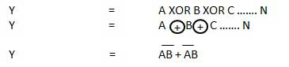

**Logic diagram**

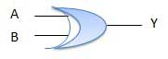

**Truth Table**

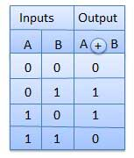

**XNOR Gate**

XNOR gate is a special type of gate. It can be used in the half adder, full adder and subtractor. The exclusive-NOR gate is abbreviated as EX-NOR gate or sometime as X-NOR gate. It has n input (n >= 2) and one output.

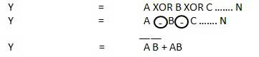

**Logic diagram**

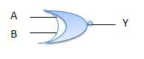

**Truth Table**

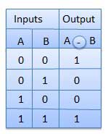

Combinational circuit is a circuit in which we combine the different gates in the circuit, for example encoder, decoder, multiplexer and demultiplexer. Some of the characteristics of combinational circuits are following −

* The output of combinational circuit at any instant of time, depends only on the levels present at input terminals.
* The combinational circuit do not use any memory. The previous state of input does not have any effect on the present state of the circuit.
* A combinational circuit can have an n number of inputs and m number of outputs.

### Block diagram

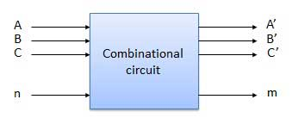

We're going to elaborate few important combinational circuits as follows.

## Half Adder

Half adder is a combinational logic circuit with two inputs and two outputs. The half adder circuit is designed to add two single bit binary number A and B. It is the basic building block for addition of two **single** bit numbers. This circuit has two outputs **carry** and **sum**.

### Block diagram

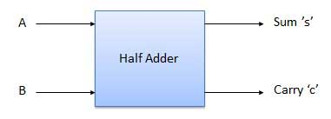

### Truth Table

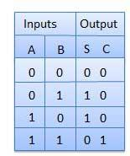

### Circuit Diagram

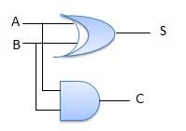

## Full Adder

Full adder is developed to overcome the drawback of Half Adder circuit. It can add two one-bit numbers A and B, and carry c. The full adder is a three input and two output combinational circuit.

### Block diagram

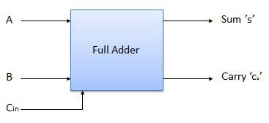

### Truth Table

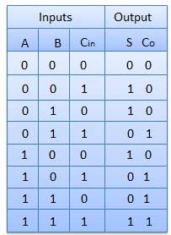

### Circuit Diagram

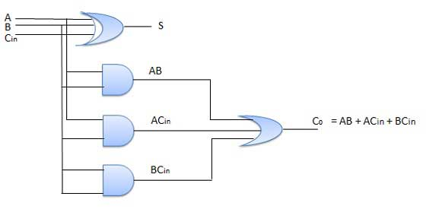

## N-Bit Parallel Adder

The Full Adder is capable of adding only two single digit binary number along with a carry input. But in practical we need to add binary numbers which are much longer than just one bit. To add two n-bit binary numbers we need to use the n-bit parallel adder. It uses a number of full adders in cascade. The carry output of the previous full adder is connected to carry input of the next full adder.

### 4 Bit Parallel Adder

In the block diagram, A0 and B0 represent the LSB of the four bit words A and B. Hence Full Adder-0 is the lowest stage. Hence its Cin has been permanently made 0. The rest of the connections are exactly same as those of n-bit parallel adder is shown in fig. The four bit parallel adder is a very common logic circuit.

### Block diagram

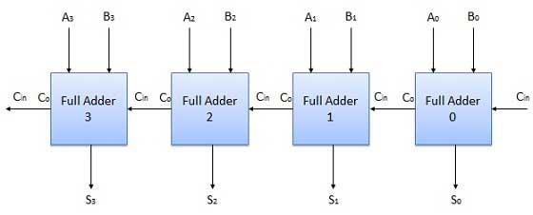

## N-Bit Parallel Subtractor

The subtraction can be carried out by taking the 1's or 2's complement of the number to be subtracted. For example we can perform the subtraction (A-B) by adding either 1's or 2's complement of B to A. That means we can use a binary adder to perform the binary subtraction.

### 4 Bit Parallel Subtractor

The number to be subtracted (B) is first passed through inverters to obtain its 1's complement. The 4-bit adder then adds A and 2's complement of B to produce the subtraction. S3 S2 S1 S0 represents the result of binary subtraction (A-B) and carry output Cout represents the polarity of the result. If A > B then Cout = 0 and the result of binary form (A-B) then Cout = 1 and the result is in the 2's complement form.

### Block diagram

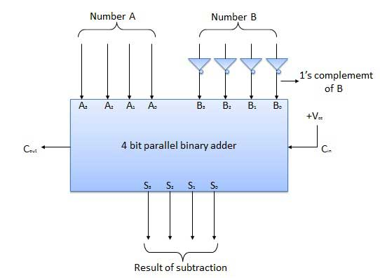

## Half Subtractors

Half subtractor is a combination circuit with two inputs and two outputs (difference and borrow). It produces the difference between the two binary bits at the input and also produces an output (Borrow) to indicate if a 1 has been borrowed. In the subtraction (A-B), A is called as Minuend bit and B is called as Subtrahend bit.

### Truth Table

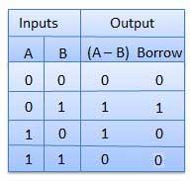

### Circuit Diagram

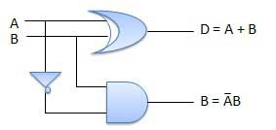

## Full Subtractors

The disadvantage of a half subtractor is overcome by full subtractor. The full subtractor is a combinational circuit with three inputs A,B,C and two output D and C'. A is the 'minuend', B is 'subtrahend', C is the 'borrow' produced by the previous stage, D is the difference output and C' is the borrow output.

### Truth Table

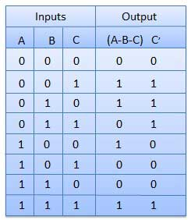

### Circuit Diagram

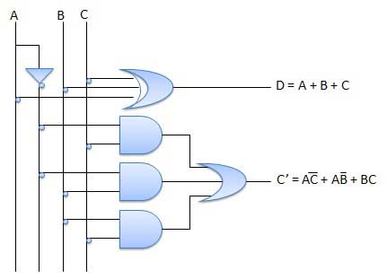

## Multiplexers

Multiplexer is a special type of combinational circuit. There are n-data inputs, one output and m select inputs with 2m = n. It is a digital circuit which selects one of the n data inputs and routes it to the output. The selection of one of the n inputs is done by the selected inputs. Depending on the digital code applied at the selected inputs, one out of n data sources is selected and transmitted to the single output Y. E is called the strobe or enable input which is useful for the cascading. It is generally an active low terminal that means it will perform the required operation when it is low.

### Block diagram

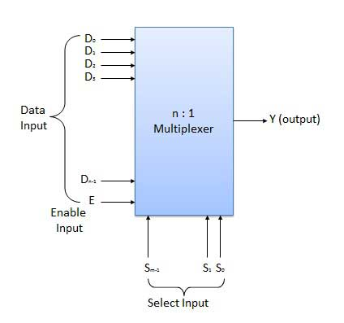

Multiplexers come in multiple variations

* 2 : 1 multiplexer
* 4 : 1 multiplexer
* 16 : 1 multiplexer
* 32 : 1 multiplexer

### Block Diagram

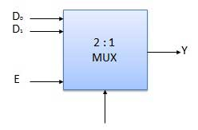

### Truth Table

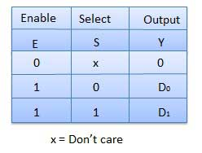

## Demultiplexers

A demultiplexer performs the reverse operation of a multiplexer i.e. it receives one input and distributes it over several outputs. It has only one input, n outputs, m select input. At a time only one output line is selected by the select lines and the input is transmitted to the selected output line. A de-multiplexer is equivalent to a single pole multiple way switch as shown in fig.

Demultiplexers comes in multiple variations.

* 1 : 2 demultiplexer
* 1 : 4 demultiplexer
* 1 : 16 demultiplexer
* 1 : 32 demultiplexer

### Block diagram

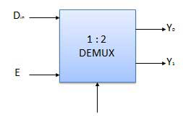

### Truth Table

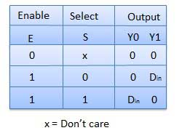

## Decoder

A decoder is a combinational circuit. It has n input and to a maximum m = 2n outputs. Decoder is identical to a demultiplexer without any data input. It performs operations which are exactly opposite to those of an encoder.

### Block diagram

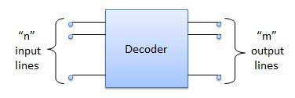

Examples of Decoders are following.

* Code converters
* BCD to seven segment decoders
* Nixie tube decoders
* Relay actuator

## 2 to 4 Line Decoder

The block diagram of 2 to 4 line decoder is shown in the fig. A and B are the two inputs where D through D are the four outputs. Truth table explains the operations of a decoder. It shows that each output is 1 for only a specific combination of inputs.

### Block diagram

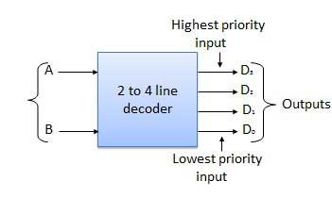

### Truth Table

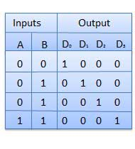

### Logic Circuit

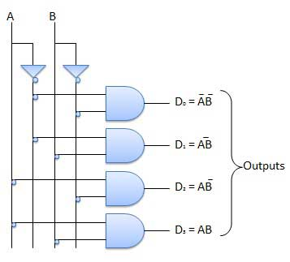

## Encoder

Encoder is a combinational circuit which is designed to perform the inverse operation of the decoder. An encoder has n number of input lines and m number of output lines. An encoder produces an m bit binary code corresponding to the digital input number. The encoder accepts an n input digital word and converts it into an m bit another digital word.

### Block diagram

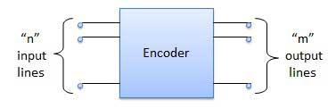

Examples of Encoders are following.

* Priority encoders
* Decimal to BCD encoder
* Octal to binary encoder
* Hexadecimal to binary encoder

## Priority Encoder

This is a special type of encoder. Priority is given to the input lines. If two or more input line are 1 at the same time, then the input line with highest priority will be considered. There are four input D0, D1, D2, D3 and two output Y0, Y1. Out of the four input D3 has the highest priority and D0 has the lowest priority. That means if D3 = 1 then Y1 Y1 = 11 irrespective of the other inputs. Similarly if D3 = 0 and D2 = 1 then Y1 Y0 = 10 irrespective of the other inputs.

### Block diagram

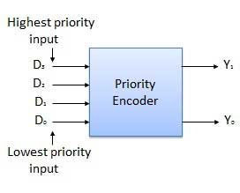

### Truth Table

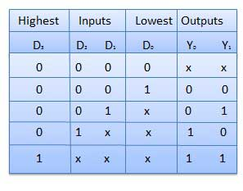

### Logic Circuit

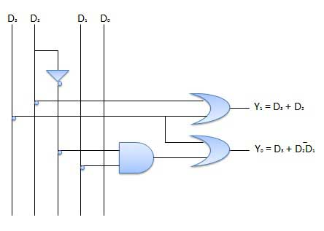

## Block diagram

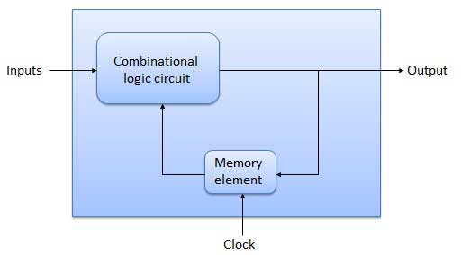

## Flip Flop

Flip flop is a sequential circuit which generally samples its inputs and changes its outputs only at particular instants of time and not continuously. Flip flop is said to be edge sensitive or edge triggered rather than being level triggered like latches.

## S-R Flip Flop

It is basically S-R latch using NAND gates with an additional **enable** input. It is also called as level triggered SR-FF. For this, circuit in output will take place if and only if the enable input (E) is made active. In short this circuit will operate as an S-R latch if E = 1 but there is no change in the output if E = 0.

### Block Diagram

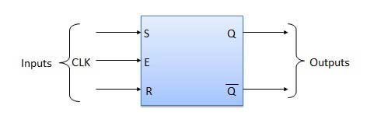

### Circuit Diagram

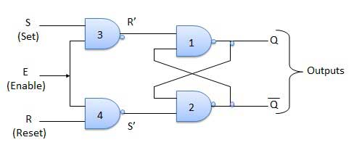

### Truth Table

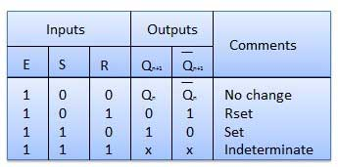

### Operation

|  |  |  |
| --- | --- | --- |
| **S.N.** | **Condition** | **Operation** |
| 1 | **S = R = 0 : No change** | If S = R = 0 then output of NAND gates 3 and 4 are forced to become 1.  Hence R' and S' both will be equal to 1. Since S' and R' are the input of the basic S-R latch using NAND gates, there will be no change in the state of outputs. |
| 2 | **S = 0, R = 1, E = 1** | Since S = 0, output of NAND-3 i.e. R' = 1 and E = 1 the output of NAND-4 i.e. S' = 0.  Hence Qn+1 = 0 and Qn+1 bar = 1. This is reset condition. |
| 3 | **S = 1, R = 0, E = 1** | Output of NAND-3 i.e. R' = 0 and output of NAND-4 i.e. S' = 1.  Hence output of S-R NAND latch is Qn+1 = 1 and Qn+1 bar = 0. This is the reset condition. |
| 4 | **S = 1, R = 1, E = 1** | As S = 1, R = 1 and E = 1, the output of NAND gates 3 and 4 both are 0 i.e. S' = R' = 0.  Hence the **Race** condition will occur in the basic NAND latch. |

## Master Slave JK Flip Flop

Master slave JK FF is a cascade of two S-R FF with feedback from the output of second to input of first. Master is a positive level triggered. But due to the presence of the inverter in the clock line, the slave will respond to the negative level. Hence when the clock = 1 (positive level) the master is active and the slave is inactive. Whereas when clock = 0 (low level) the slave is active and master is inactive.

### Circuit Diagram

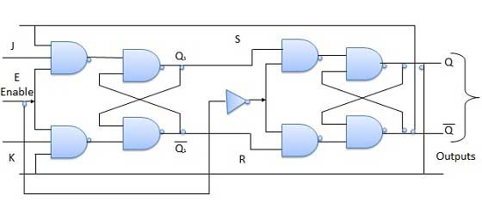

### Truth Table

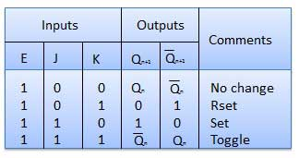

### Operation

|  |  |  |
| --- | --- | --- |
| **S.N.** | **Condition** | **Operation** |
| 1 | **J = K = 0 (No change)** | When clock = 0, the slave becomes active and master is inactive. But since the S and R inputs have not changed, the slave outputs will also remain unchanged. Therefore outputs will not change if J = K =0. |
| 2 | **J = 0 and K = 1 (Reset)** | Clock = 1 − Master active, slave inactive. Therefore outputs of the master become Q1 = 0 and Q1 bar = 1. That means S = 0 and R =1.  Clock = 0 − Slave active, master inactive. Therefore outputs of the slave become Q = 0 and Q bar = 1.  Again clock = 1 − Master active, slave inactive. Therefore even with the changed outputs Q = 0 and Q bar = 1 fed back to master, its output will be Q1 = 0 and Q1 bar = 1. That means S = 0 and R = 1.  Hence with clock = 0 and slave becoming active the outputs of slave will remain Q = 0 and Q bar = 1. Thus we get a stable output from the Master slave. |
| 3 | **J = 1 and K = 0 (Set)** | Clock = 1 − Master active, slave inactive. Therefore outputs of the master become Q1 = 1 and Q1 bar = 0. That means S = 1 and R =0.  Clock = 0 − Slave active, master inactive. Therefore outputs of the slave become Q = 1 and Q bar = 0.  Again clock = 1 − then it can be shown that the outputs of the slave are stabilized to Q = 1 and Q bar = 0. |
| 4 | **J = K = 1 (Toggle)** | Clock = 1 − Master active, slave inactive. Outputs of master will toggle. So S and R also will be inverted.  Clock = 0 − Slave active, master inactive. Outputs of slave will toggle.  These changed output are returned back to the master inputs. But since clock = 0, the master is still inactive. So it does not respond to these changed outputs. This avoids the multiple toggling which leads to the race around condition. The master slave flip flop will avoid the race around condition. |

## Delay Flip Flop / D Flip Flop

Delay Flip Flop or D Flip Flop is the simple gated S-R latch with a NAND inverter connected between S and R inputs. It has only one input. The input data is appearing at the output after some time. Due to this data delay between i/p and o/p, it is called delay flip flop. S and R will be the complements of each other due to NAND inverter. Hence S = R = 0 or S = R = 1, these input condition will never appear. This problem is avoid by SR = 00 and SR = 1 conditions.

### Block Diagram

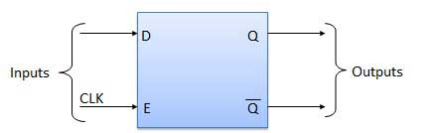

### Circuit Diagram

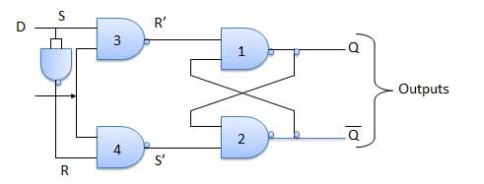

### Truth Table

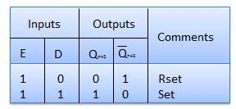

### Operation

|  |  |  |
| --- | --- | --- |
| **S.N.** | **Condition** | **Operation** |
| 1 | **E = 0** | Latch is disabled. Hence no change in output. |
| 2 | **E = 1 and D = 0** | If E = 1 and D = 0 then S = 0 and R = 1. Hence irrespective of the present state, the next state is Qn+1 = 0 and Qn+1 bar = 1. This is the reset condition. |
| 3 | **E = 1 and D = 1** | If E = 1 and D = 1, then S = 1 and R = 0. This will set the latch and Qn+1 = 1 and Qn+1 bar = 0 irrespective of the present state. |

## Toggle Flip Flop / T Flip Flop

Toggle flip flop is basically a JK flip flop with J and K terminals permanently connected together. It has only input denoted by **T** as shown in the Symbol Diagram. The symbol for positive edge triggered T flip flop is shown in the Block Diagram.

### Symbol Diagram

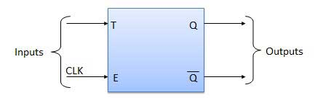

### Block Diagram

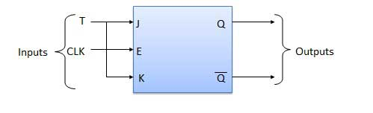

### Truth Table

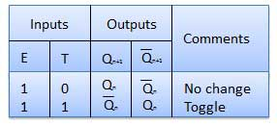

### Operation

|  |  |  |
| --- | --- | --- |
| **S.N.** | **Condition** | **Operation** |
| 1 | **T = 0, J = K = 0** | The output Q and Q bar won't change |
| 2 | **T = 1, J = K = 1** | Output will toggle corresponding to every leading edge of clock signal. |